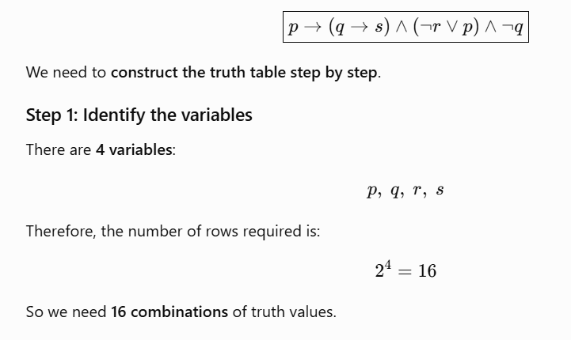
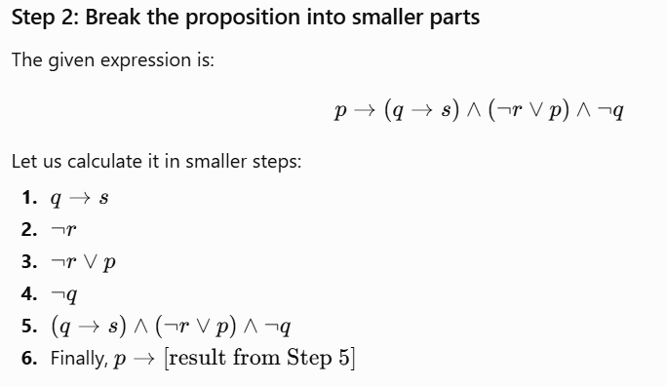

Step 3: Complete truth table
p | q | r | s | q → s | ¬r | ¬r ∨ p | ¬q | (q→s) ∧ (¬r∨p) ∧ ¬q | Final
T | T | T | T | T | F | T | F | F | F
T | T | T | F | F | F | T | F | F | F
T | T | F | T | T | T | T | F | F | F
T | T | F | F | F | T | T | F | F | F
T | F | T | T | T | F | T | T | T | T
T | F | T | F | T | F | T | T | T | T
T | F | F | T | T | T | T | T | T | T
T | F | F | F | T | T | T | T | T | T
F | T | T | T | T | F | F | F | F | T
F | T | T | F | F | F | F | F | F | T
F | T | F | T | T | T | T | F | F | T
F | T | F | F | F | T | T | F | F | T
F | F | T | T | T | F | F | T | F | T
F | F | T | F | T | F | F | T | F | T
F | F | F | T | T | T | T | T | T | T
F | F | F | F | T | T | T | T | T | T

